4.2 Instruction for running XT-OBS-Studio Application

To build XT-OBS-Studio Application (Refer Document: Obs install and Setup instruction)

A To run XT-OBS-Studio Application

- Open Obs application
- Go to the settings button located at the right bottom side of the application
- Go to stream left side of the panel
- Select XT-streaming
- Update Server with URL which tcp_server is running
- Enter Stream key

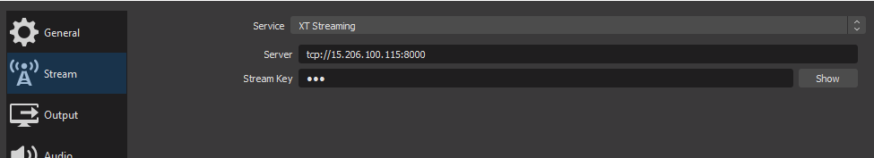

- Click on apply and then ok
- Now click on the start streaming button located at the right bottom side of the application.

